进入对应dashboard f12查看请求路径和负载（header）
https://grafana.lanhc.com/ hqu341 12345678
Auth鉴权 glsa_U1ZOUbuzhKyDE7BjD6b2hf7ag7qpz4TW_dc5fc8b5
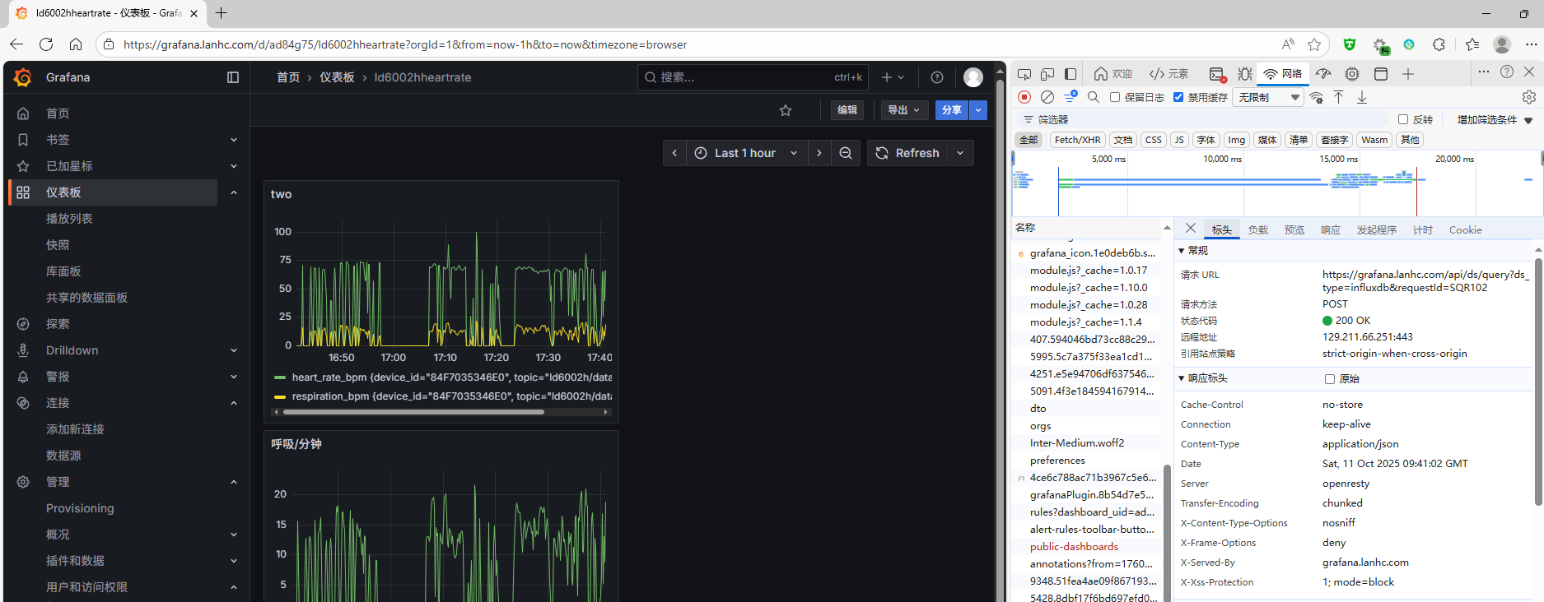
负载示例{
"queries": [
{
"datasource": {
"type": "influxdb",
"uid": "bf0ly1pg9j01sa"
},
"query": "from(bucket: \"vitals_data\")\r\n |> range(start: v.timeRangeStart, stop: v.timeRangeStop)\r\n |> filter(fn: (r) => r[\"device_id\"] == \"84F7035346E0\")\r\n |> filter(fn: (r) => r[\"_field\"] == \"heart_rate_bpm\" or r[\"_field\"] == \"respiration_bpm\")\r\n |> aggregateWindow(every: v.windowPeriod, fn: mean, createEmpty: false)\r\n |> yield(name: \"mean\")",
"refId": "A",
"datasourceId": 4,
"intervalMs": 30000,
"maxDataPoints": 432
}
],
"from": "1760164430243",
"to": "1760175230243"
}

